Analysis of shooting
Name: Click here to enter text.
Analysis of shooting within a game of football is an area often focused upon by a coach. The following information is an example of a hand notational analysis system which could be used. Use the information provided to develop your own analysis system and then put it into practice by recording information for a match situation.

Pitch Template

The pitch template method is the most effective way of locating where on the court or pitch an event took place. The easiest way is to divide areas of the pitch up into segments and number them, each different number represents a n area of the playing area.

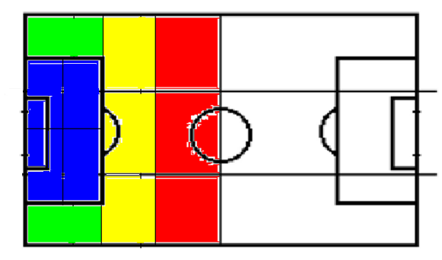
A
B
D
C
3
7
4
1
5
2
6
8

Figure 1: Example pitch template which maybe used for data collection.

Data Collection Table for Shooting
It is vital to identify the Key Performance Indicators (KPI) that are important for the coach to know with the aim of improving performance levels. Below is some example information that could be used to analyse a teams shooting accuracy.
Key
Time:
When in the game is it – minute the shot occurred

Where:
Where was the ball struck from in the zones (use the pitch template)

Build up play:
How many passes were made before the shot was taken – look at the tactical play within the game.

How – the technique used:

- Header – H
- Right foot – RF
- Left foot – LF
- Volley – V
- Half Volley – HV
- In step – IS

Under pressure:
If the opposition is within a metre of player taking the shot
- Opponent within a meter -
- Player free of opponents -

Success:
- On target -
- Off target -

Where in net:
- Bottom Left - BL
- Bottom Right - BR
- Top Left - TL
- Top Right – TR
- Lower middle – LM
- Top middle – TM

Off target
- Wide Left– WL
- Wide Right– WR
- Over bar – OB

Data Collection Table
Collection tables are vital to record accurate and concise information. Table 1 is an example data collection table which could be used to analyse a teams shooting. Notice the use of short hand codes to make the table easy to complete whilst watching performance.

Table 1: Example data collection table and method to analyse a teams shooting performance in football.
Time | Build up | Where/zone | How | Under pressure | Success | Place of shot | Result
6 | 1 | A | LF |  |  | OB
7 | 3 | B | H |  |  | WR
8 | 6 | B | H |  |  | OB
13 | 0 | 4 | LF-IS |  |  | OB
15 | 3 | 5 | LF-V |  |  | WL
23 | 4 | 5 | RF |  |  | BR | Saved
26 | 2 | 2 | LF |  |  | LM | Saved
31 | 6 | C | LF |  |  | WR
46 | 3 | C | H |  |  | BR | Goal
48 | 5 | 7 | RF |  |  | LM | Saved
52 | 6 | C | H |  |  | OB
67 | 1 | A | RF |  |  | BR | Saved
75 | 2 | C | RF |  |  | BR | Saved
82 | 3 | D | H |  |  | TM | Saved
87 | 2 | C | H |  |  | BL | Goal

